Lecture Notes for Midterm

Lecture 1
- Passcode: f#T^kNh6
- Introduction
  - Terminology
    - Problem: a type of input and type of output defined by finite digital data structure and mathematical notations
    - Ex:
The <problem name> problem is:
input: <definition of input objects>
output: <definition of output objects>
    - Ex:
Minimum problem is:
Input: A list of n > 0 comparable objects
Output: least element in L
  - Problem Instance: a specific, concrete input to a problem
    - Ex: lists [7,2,1,9] is an instance of the minimum problem.
An empty list is not a valid instance since we need n>0
    - We are giving a value for each input variable.
    - WE ALWAYS NEED INPUTS!
  - Process: A series of actions directed to some end
  - Algorithm: Ordered sequence of finite number of steps, each executed in finite time
    - Ex:
* Algorithm for adding 2 numbers
* Algorithm for finding the shortest path in a network
* Algorithm to search for an article on the web
    - Shortest Path in a graph
      - input: start vertex, destination vertex
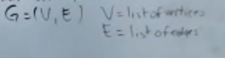
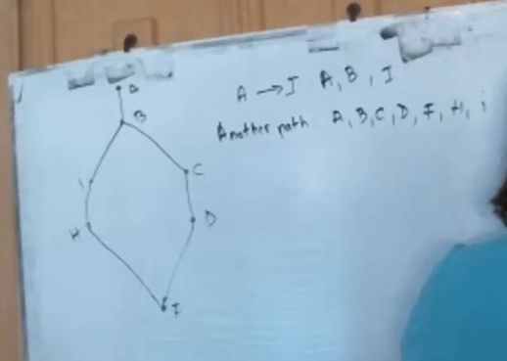

        - Output: a list of vertices
          - P= 5,….
    - Searching for an article
      - Input: string Title on the web
      - Output: yes (found) / no (not found), url
  - Pseudocode
    - Pseudocode: human-redable format for communicating algorithms
    - Similar to program source code
    - Ex. Pseudocode for minimum problem is:
      - Let min = first elmenet of L (there is one since n>0)
For each element in L do
if (min > element) then let min = element
Return min
  - How to measure quality of an algorithm
    - Mesaured in terms of resources it consumes when executed
    - Ex of resources
* memory
* communication bandwith
* processor time
    - Time and memory need
* Shorter execution time = better quality (time complexity) ← More important
* Smaller memory = better quality (space complexity)
    - Measure algorithm on universal model of computation called RAM
    - Model of computation and implementation is RAM model
      - One memory (infinite)
      - One processor
      - Instructions are executed sequentially
        - Simple: assignment, addition, multiplication, etc.

  - Implementation
    - Implementation: executable computer code that follows process defined by algorithms
    - Ex.

    - 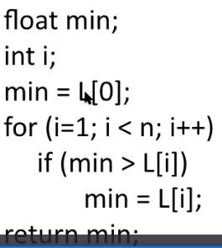
    - You are at time 1:38:33

Lecture 5
- Passcode: $D.2o51!

